***Project Management***

***Process and Training Guide***

**By John F. Filicetti, PMP, MBA**

**Table of Contents**

WHAT IS A PROJECT? 5

PROJECT MANAGEMENT OVERVIEW 6

PROJECT MANAGEMENT FOCUS 6

Control 6

Communications 7

*Communications Planning 7*

*Project Communications Management 8*

Documentation 8

PROJECT ROLES AND RESPONSIBILITIES 9

PROJECT MANAGEMENT PHASES 11

DURING ALL PHASES 12

Duties of the Project Manager 12

Duties of the Project Team 12

DURING THE CONCEPT PHASE 13

Duties of the Project Manager 13

Duties of the Project Team 13

DURING THE PLAN/DESIGN PHASE 13

Duties of the Project Manager 13

Duties of the Project Team 14

DURING THE IMPLEMENT/BUILD PHASE 14

Duties of the Project Manager 14

Duties of the Project Team 15

DURING THE DEPLOY/MAINTAIN PHASE 15

Duties of the Project Manager 15

Duties of the Project Team 16

DURING THE CLOSE PHASE 16

Duties of the Project Manager 16

PHASE DETAILS 16

PHASE 1 – CONCEPT - OVERVIEW 16

PHASE 1 – CONCEPT – SUGGESTED DETAILED STEPS 17

Receive Project Requests and Review Alternatives 17

Gather Information for Selection 17

Communicate Approved Project List 17

PHASE 2 – PLAN/DESIGN – SUGGESTED DETAILED STEPS 18

Name Project Sponsor 19

Appoint the Project Manager 19

Select and Prepare Project Team 20

Gather Project Requirements 20

Develop Project Schedule 20

Develop Project Management Plan 22

*Project Cost Plan Development 24*

*Project Risk 26*

Develop Project Designs 27

Approve All Project Documents 28

Equip Project (optional) 28

PHASE 3 – IMPLEMENTATION/BUILD PHASE 28

Project Management Plan/Project Schedule Execution 29

Verify Solution 29

Control 29

Information Distribution 30

Change Control 30

Report Performance 31

Quality Assurance 31

User Training 32

Prepare for Transition 32

Acceptance Testing and Approval 32

PHASE 4 – DEPLOY/SUPPORT PHASE 33

CLOSE PHASE 33

Conduct Project Closeout Meeting 34

Project Team Meeting 34

Archive Project Documents 35

Celebrate!!! 35

Release Project Team Members 35

Duties of the Project Manager During Closeout Phase 35

The intent of this document will be a guide for project managers through the phases of projects management to provide consist and repeatable project delivery.

As you will learn, the key to good project management is communications, planning, and teamwork. Whether you are working a $100,000 project or a $10,000,000 project; you should follow the same procedures, provide the same deliverables, and constantly over-communicate to all stakeholders. This is project management with a “plan” and will ensure your project success so you can direct your energies where they belong.

This document will help you with:

* The basics of project management
* Key project roles and responsibilities
* The procedures to ensure a successful engagement including key deliverables based on experience and validated PMI process

# **What is a Project?**

Work generally involves either operations or projects. The two may have some common and unique characteristics. The common characteristics are:

* They are performed by people
* They are constrained by limited resources
* They are planned, executed, and controlled

Operations and projects differ primarily because operations are ongoing and repetitive while projects are temporary and unique. Projects are undertaken at all levels of the organization. They may involve a single person or many thousands. They may require less than 100 hours to complete or a number of years. Projects may involve a single unit of one organization or may cross-organizational boundaries as in joint ventures and partnering. Projects are often critical components of the performing organization’s business strategy.

A project can be defined in terms of its distinctive characteristics:

* A project is a temporary endeavor undertaken to create a unique product or service—it is unique
* Temporary means every project has a definite beginning and a definite end
* A project uses resources
* A project causes change
* It meets pre-established goals for cost, schedule, and quality

# **Project Management Overview**

Project management is the application of knowledge, skills, and tools to project activities in order to meet stakeholders’ needs and expectations. Meeting or exceeding stakeholder needs and expectations invariably involves balancing competing demands among:

* Scope, time, cost and quality (the Triple Constraint)
* Stakeholders with differing needs and expectations
* Identified requirements (needs) and unidentified requirements (expectations)

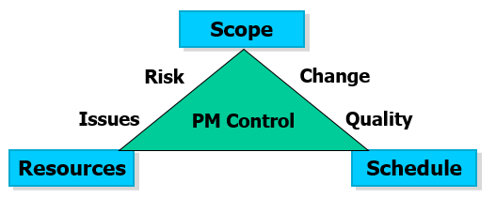

An action, or failure to take action, in one area of project management will usually affect other areas. The interactions may be straightforward and well understood, or they may be subtle and uncertain. For example, a scope change will almost always affect project cost or schedule (the Triple Constraint of Project Management), but it may or may not affect team morale or product quality. Project managers also focus on providing a solution while controlling the quality, costs, change, and risks. Successful project management requires actively managing these areas.

# **Project Management Focus**

When people think of Project Management, they generally think of the control aspect of the position. This is very important, but we will also look at two other key elements: Communications and Documentation.

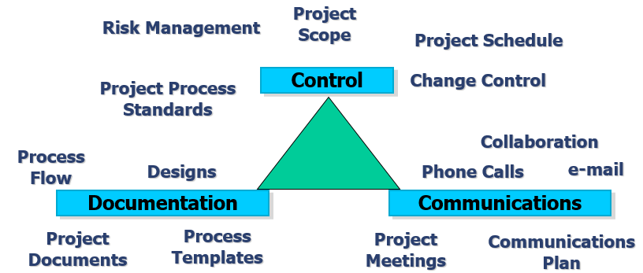

## **Control**

Control is a broad subject dealing with every aspect of managing a project. Among other topics, it includes:

* Scope Control by gathering the client’s requirements to define the scope and objectives of the project and managing to those definitions during project implementation
* Resource Control by assigning project team members to project tasks and managing the tasks to completion according to project objectives and project team assignments
* Schedule control by controlling changes to the project schedule
* Cost Control by establishing and controlling changes to the project budget
* Risk Control through risk identification and management
* Change Control by controlling changes across the entire project scope
* Quality Control by monitoring specific project results to determine if they comply with relevant quality standards and identifying ways to eliminate causes of unsatisfactory performance
* Equipment Procurement and Control by managing the procurement, delivery, inventory, storage, build, and deployment of the project equipment
* People Control by managing work relationships through motivation, delegation, supervision, team building, conflict management, and other techniques
* Personal Control by managing oneself through personal time management, stress management, and other techniques

General management skills provide much of the foundation for building project management skills. These skills are often overlooked by people trying to become project managers. A good project manager will have experience and training in:

* Finance, accounting, sales, marketing, research, development, manufacturing, and distribution
* Strategic, tactical, and operation planning
* Organizational structures and behavior, personnel administration, compensation, benefits and career paths

The Control aspect of the position is one of managing resources, budgets, time constraints, equipment, schedules, etc. We will cover these in more detail, but first the other key elements.

## **Communications**

Communications skills are used to exchange information. The sender is responsible for making the information clear, unambiguous, and complete so the receiver can receive it correctly and for confirming it is properly understood. The receiver is responsible for making sure the information is received in its entirety and understood correctly. Communicating has many dimensions:

### **Communications Planning**

Communications planning involves determining the information and communications needs of the project stakeholders and the other project team members: who needs what information, when will they need it, and how will it be given to them. The information needs of the various stakeholders and team members should be analyzed to develop a methodical and logical view of their information needs and sources to meet those needs. The analysis should consider methods and technologies suited to the project that will provide the information needed.

While all projects share the need to communicate project information, the informational needs and the methods of distribution vary widely. Identifying the informational needs of the stakeholders and determining a suitable means of meeting those needs is an important factor for project success.

On most projects, the majority of communications planning is done as part of the earliest project phases. The results of this process should be reviewed regularly throughout the project and revised as needed to ensure continued applicability. On many projects, the Project Review ensures project communication is high.

Communications planning is often tightly linked with organizational planning since the project’s organizational structure will have a major effect on the project’s communications requirements.

### **Project Communications Management**

Once you know who needs the information and when they need it, you will have to use Project Communications Management. Project Communications Management includes the processes required to ensure timely and appropriate generation, collection, dissemination, storage, archival, and ultimate disposal of project information. It provides the critical links among people, ideas, and information that are necessary for success. Everyone involved in the project must be prepared to send and receive communications and must understand how the communications they are involved in as individuals affect the project as a whole. The Communication Management Plan documents:

* **To whom** information (status reports, data, schedule, technical documentation, etc.) will flow (This structure must be compatible with the responsibilities and reporting relationships described by the project organization chart or Roles and Responsibility chart)
* **What** methods (written reports, meetings, etc.) will be used to distribute various types of information along with a description of the information to be distributed, including format, content, level of detail, and conventions/definitions to be used
* **When**, or the frequency of the information flow
* **Where** the information is stored along with methods for accessing the information between scheduled communications
* A method for updating and refining the communications management plans as the project progresses and develops

## **Documentation**

The need for documentation during the life of a project cannot be stressed too much. The more times you can document a conversation, a process, a plan, a schedule; and have it validated by a team member or a customer, the more you will be seen to be organized and in control of the project.

All documents should be collected and stored in the project repository if they are in softcopy form or in the project folder if they can only be collected in hardcopy. The repository will allow you to easily share information with other project team members and the customer and will help you avoid hunting around for information. At the completion of a project, the information in the repository should be kept for a number of years for audit and reference purposes. All information should be stored in the repository. Nothing is too trivial if it concerns the project.

# **Project Roles and Responsibilities**

People involved with projects can have various roles such as:

**Customer/Business Owner**

* Has the need for the work and can articulate the project requirements
* A visionary, evangelist, and strong advocate for the project
* Raises awareness about the project effort and output
* Accountable for project investment and return on investment
* Builds support for the project

**Project Stakeholder**

* Someone who may be affected by project outcome or activities
* Has a vested interest in the project deliverables and/or their impact on the organization
* May provide content / information to the sponsor and team
* Must buy-in to solutions generated by the project
* May have to implement organizational or procedural changes which result from the project

**Project Sponsor**

* A member of the top management team having the greatest investment in the project
* Represents the project at corporate level with ultimate ownership of the project from the implementation standpoint
* An advocate for needed resources
* Helps the PM overcome organizational conflicts and barriers to project performance
* Ensure timely decision making and issue escalation
* Coaches the project manager as needed
* Provides project oversight and review

**Project Manager (PM)**

* Appointed to lead the project
* Primary project interface for customer and stakeholders during all project phases
* Manages project cost, scope, resources, schedule, risk, change, issues, and quality
* Sole source and contact for all project information
* Enables project team members to do their job by acting as conduit for information and activities
* Works with project team members to prepare project documentation

**Analyst**

* Works with customer, project stakeholders, and project team to:
  + Define business needs and facilitate prioritization
  + Identify Stakeholder and User Classes
  + Elicit Requirements
    - Translate customer requirements into something the project team can understand, and then translates project teams' questions into something the customer can understand
  + Analyze Requirements
  + Specify Requirements (write requirements specifications)
  + Model the Requirements
  + Validate requirements
  + Manage Requirements
* Help to scope the solution, identify potential areas of automation and reengineer the underlying business process

**Finance**

* Works with project manager, and project team to:
* Sets the project budget and determines capital feasibility
* Validates Capital and Operational results
* Issue escalation and resolution specifically related to a decrease or overage in the capital budget
* Close capital project
  + When the project is complete and ready for its intended use
  + When it is no longer probable the project will be completed or placed into service

**Quality Assurance (QA)**

* Systematically monitors the attributes, properties, and characteristics of output to meet the expectations and needs of customers and users
* Optimizes project team productivity by monitoring the processes undertaken to develop project deliverables, project organization, and project controls
  + Helps to identify project risks and issues
  + Focus on Process and Change throughout the project
  + Proactive

**Quality Control (QC)**

* Inspects project output to prevent undetected defects or the rendering of faulty services as well as checking for conformity with applicable standards
  + Focus on quality of output
  + Reactive

**Subject Matter Expert (SME)**

* Has special, in-depth knowledge of a business area or technology
* Helps team to define and select an appropriate solution and ensures the solution is being correctly utilized
* Identifies issues and concerns from experience
* Enhances the project team's understanding and ability to perform project activities

**Other Project Delivery Personnel**

* Under the management of the project manager, responsible for executing project tasks and producing project
* Identify and communicate risks, problems, issues, or concerns in an appropriate and timely manner to the project manager
* Provide regular progress reporting to project manager

# **Project Management Phases**

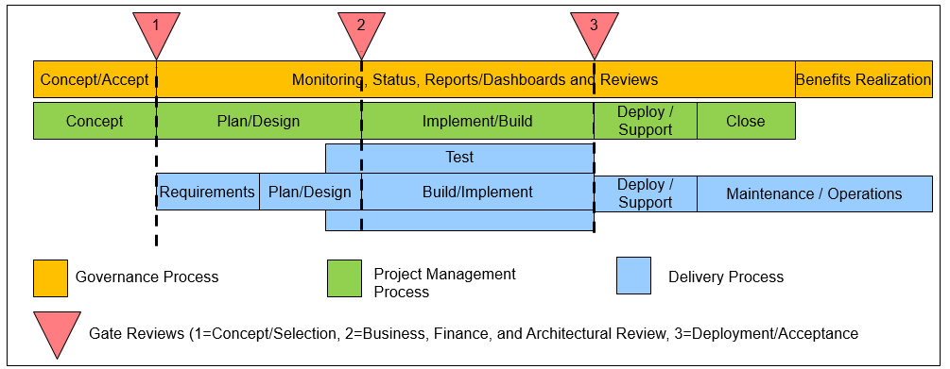

* **Concept Phase:** Information is gathered to define, analyze, align, prioritize, and approve a proposed project. If the project is selected, a timeframe is selected and resources can be committed based on the timeframe
* **Plan/Design Phase:** Requirements are gathered to create the scope, schedule, and deliverables of the project. Project schedule, documents/plans, and designs are created to define the project.
* **Implement/Build Phase:** Using the documents and schedule created during the Plan/Design phase, the project manager will lead the team to implement the project deliverables while ensuring quality. The project team will ensure project objectives are met by monitoring and measuring progress and taking corrective action when necessary.
* **Deploy/Maintain Phase:** Transitions the project solution to a new business capability. The project team may be called on to maintain the project solution for a short time before handing over to operations/maintenance
* **Close Phase:** After formal acceptance of the project, the project manager leads the project team in bringing the project to an orderly end

This process should be repeatable for all projects with moderate changes. The remainder of this document will detail the process and provide examples.

# **During All Phases**

## **Duties of the Project Manager**

* Manages the collaborative project repository environment for the program or project and updates the repository on a timely basis
* Responsible for having most current project content
* All meetings require a Meeting Report to be completed and filed in the Project Repository. The best way to use the Meeting Report is to fill in the meeting information such as time, location and agenda and send the Meeting Report to the meeting attendees. During or after the meeting, fill in the minutes with any action items noted; distribute the final document to the team and post in the Project Repository for project stakeholders.
* PM manages Change Control. Once the scope, schedule, and finances are set and approved, any change requested will require a Change Request. The request will be reviewed by the PM for impact and cost and be managed through the Change Control process. Only approved changes will be managed by the project manager and included in the project. An accepted change may call for a separate project to accommodate the changes or additional funding on the current project.
* Manages Issues escalation and resolution
* PM manages Project Schedule, Costs, and Resources
* Distribute documents per the Communications Plan
* Conducts team building and team development activities (optional)
* Establishes reward and recognition systems (optional)
* Monitors & acknowledges performance
* Increases team member proximity if possible
* Provides coaching, mentoring, and assistance to team members as needed
* Works closely with functional managers to resolve team members' workload conflicts
* Ensures needed training is provided to accomplish project objectives
* Identify and resolve conflicts

## **Duties of the Project Team**

* Implement project activities and creates project artifacts outlined in Project Charter, Project Management Plan, Project Schedule, and Project Designs under management and direction of Project Manager
* Create and update project documents as called for and ensure all documents are posted to the project repository
* Distribute documents per the Communications Plan as directed by the PM
* Using the project repository, keep Project Manager and project stakeholders informed of all project activities and issues
* All project team members responsible for having most current project documents from the project repository
* Finish timecards or project activity updates on timely basis (optional)
* Provide information for Status Report

# **During the Concept Phase**

## **Duties of the Project Manager**

* Project manager may be called on as a SME during Concept phase to assist in gathering or analyzing documents/information needed to score, prioritize, and select proposed project.
* Any meetings require a Meeting Report to be completed and filed in the project repository
* If required, a project manager or analyst my
* If required, PM participates in project pricing decision and creates Cost Estimates
* PM may be called on to create the Business Case and Project Summary

## **Duties of the Project Team**

* If required, an analyst my assist by gathering documents/information needed to score, prioritize, and select proposed project

# **During the Plan/Design Phase**

## **Duties of the Project Manager**

* Ensures Requirements are gathered, analyzed, and filed in the project repository
* PM uses Requirements to create the project objectives and scope statement in the Project Management Plan, Scope of Work, or Project Charter
* PM ensures assigned project analysts use the Requirements to create Use Cases/User Stories and proposed project deliverables.
* PM Ensures Use Cases, User Stories, Project Deliverables are used to make Test Cases, Test Plan, Acceptance Plan and there is complete traceability
* PM creates Communication Plan taking into account all stakeholders, what information is needed, when it is needed, how it is delivered, and where it is stored
* PM creates the Project Schedule and includes the timeframe and milestones in the Project Management Plan or Project Repository
* Using the project schedule, PM creates initial Cost Plan for approval.
* PM completes Risk Assessment and Risk Management Plan. Risk items qualified, quantified (normally % probability x $ impact = $ Exposure). Trigger events are noted and a Risk Management approached is noted if the trigger event occurs. A management reserve may be created to manage the total Exposure if this is done in your company. Risks and Trigger Events can be managed and reviewed during weekly status meeting.
* Creates and manages Issues Matrix for use during project execution. All issues are escalated by the project manager and managed to resolution
* Creates Project Status Report on a regular basis, distributes the report to stakeholders, and posts the report to the project repository
* Works with Project Team to create Quality Plan
* Works with Project Team to create Training Plan if necessary
* Manages the creation, completion, distribution, and posting of the designs in the project repository
* Inspects all project artifacts for quality and presents project information to Governance if needed for Business, Finance, and Architectural Gate Review

## **Duties of the Project Team**

* Under the direction of the PM, Project Team members will complete required documents/designs.
* All information is stored in the project repository.
* Works with project team if needed for any prototyping (optional)
* Keep PM informed of any issues
* Under the direction of the PM, Project Team members will complete designs (conceptual, logical, physical, etc.).
* All information is stored in the project repository.
* Keep PM informed of any issues.

# **During the Implement/Build Phase**

## **Duties of the Project Manager**

* Ensures all Stakeholders are notified of all testing and deployment dates
* Creates Project Status Report on a regular basis, distributes the report to stakeholders, and posts the report to the project repository
* PM chairs weekly team meeting (beginning of week)
  + Discuss period’s accomplishments
  + Discuss planned goal and activities for next period
  + Discuss any issues
* PM chairs weekly status meetings (may delegate to project team member to build communications skills)
  + PM Distributes Agenda, current Issues Matrix, and current Project Schedule
  + Discuss week accomplishments
  + Discuss proposed activities for next week
  + Review/update all open issues using Issues Matrix
* PM ensures all project documents and artifacts are stored in the project repository and distributed to Project Stakeholders per the Communications Plan
* PM manages Issue and Escalation Process. All issues are assigned to a person and managed to resolution
* PM manages and tracks Project Schedule and communicates any changes from the initial schedule
* PM manages project budget and accounts for Operational Expenses on a periodic basis and validates Capital Expenses against corporate finance solution
* PM directs the creation and testing of the Deployment and Contingency Plans

## **Duties of the Project Team**

* Under the direction of the PM, Project Team members will complete required documents/activities.
* If finance representative is involved, may work with PM on all aspects of finance
* If QA/QC is involved, will manage all project quality and provide quality information to PM
* All documents and artifacts are stored in the project repository.
* Keep PM informed of any issues.

# **During the Deploy/Maintain Phase**

## **Duties of the Project Manager**

* PM leads team in deployment of solution and maintenance prior to turnover to maintenance/operation team
* PM reviews team's work for quality ensuring scope of work matches scope of agreement with client
* PM leads User Acceptance Testing and approval of project deliverables
* PM manages Change Control
* PM manages communication to Maintenance to ensure a smooth turnover to Maintenance after deployment

## **Duties of the Project Team**

* Under the direction of the PM, Project Team members will complete deployment of accepted solution
* Project team may provide maintenance of the solution prior to hand off to maintenance/operations
* All documents and artifacts are stored in the project repository.
* Keep PM informed of any issues.

# **During the Close Phase**

## **Duties of the Project Manager**

* PM creates Closeout Form to capture Lessons Learned and Best Practices
* PM ensures all project documents are in the project repository prior to closeout
* PM chairs the Closeout and Review meeting
* PM plans for and manages the project celebration
* PM ensures all billing is handled
* PM completes a performance feedback for every team member, reviews it with the team member, and supplies it to the team member’s manager (optional)

# **Phase Details**

# **Phase 1 – Concept - Overview**

The first phase is Concept, which is committing the organization to begin the project. The purpose of this phase is to identify the need for the project, clearly define the project, identify key players, and lay the groundwork for the project and the remaining project phases. The Concept Phase also builds and maintains support for the project including commitment of budget, resources, and buy-in to the project and its anticipated results.

During the Concept Phase, all project ideas are collected and evaluated for their support of company goals and mission, feasibility, payback, ROI, risk, and other selection criteria. All projects are scored and prioritized. Any project selected is assigned a project start date based on available resources and finances. The project sponsor and project manager will be assigned when the project is ready to start.

Any activity producing a deliverable with reuse capability by another project team should be posted in the project repository and submitted for best practices.

# **Phase 1 – Concept – Suggested Detailed Steps**

## **Receive Project Requests and Review Alternatives**

Since any project chosen will require the commitment of company’s limited resources, the organization should be careful to choose the right projects.

Evaluating proposed projects is complicated by the diverse or even conflicting demands placed on decision makers by the various potential project stakeholders. These competing demands represent alternative projects from which the organization must choose before a project can be authorized and work begun. Identifying the project alternatives requires the responsible management representative to gather potential project information, needs of the organization, and priorities.

## **Gather Information for Selection**

For each project being proposed, a Business Case/Concept Proposal and Project Summary identifying the benefits to the organization if the project is completed along with the costs, timeframe, and resource needs to accomplish the project should be completed. This information will be used to analyze, score, align, prioritize and select the project and provide a quick overview of the project and its potential benefits.

An effective project selection process must be in place to ensure any prospective project is in alignment with the organization’s strategy, plans, mission, and goals. Key stakeholders should be involved with the selection process and buy into the resulting decisions. The selection should also be made in a timely manner as timeliness to market is directly impacted by the timeliness of the Concept process.

The key to effectively choosing among the various project alternatives is to first define the project selection criteria such as: the degree of strategic alignment, impact on upstream and downstream processes, impact on the business, financial return, feasibility, and other factors. Next, the selection committee should create a matrix with the project alternatives and the criteria and score each project in the matrix.

Each alternative project can then be objectively judged according to its expectedability to satisfy project selection criteria. Expert judgment and SMEs will often be required to assess the inputs to this process and may call on assistance from consultants or professional, technical associations, and Industry groups.

After the project alternatives have been evaluated, the choices should be validated with the stakeholders.

## **Communicate Approved Project List**

Communicating the project selection paves the way for the inter-organizational cooperation and smooth execution required to succeed. Be sure to identify all the stakeholders and organizations potentially affected by the project and formally communicate the project authorization in writing, electronically, or by meeting with key project stakeholders in person to discuss expectations and concerns.

# **Phase 2 – Plan/Design – Suggested Detailed Steps**

The Plan/Design phase defines the project by gathering the project requirements, creating the project charter/Project Management Plan, the project schedule, detailed project documents, and project designs to guide the project. The more thorough job done in the Planning Phase, the easier the remainder of the project will be.

Below is a representative look at the activities during the Plan/Design phase for a software project. Your project may be different and have different activities/output.

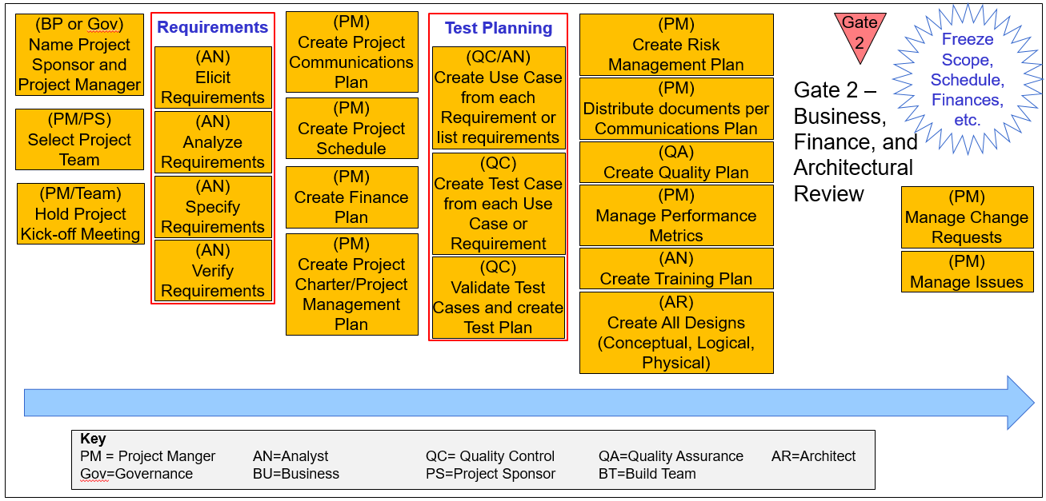

The Inputs to the Plan/Design Phase include:

* The Business Case, Project Summary, Concept Proposal
* Meeting Reports from all meetings
* Any documentation on project choices and selection criteria

The Outputs from this phase are deposited in the project repository and include:

* Meeting Reports
* Project Requirements
* Project Schedule
* Project Management Plan/Project Charter
* Other Project Management Plans
* Project Designs

Any activity producing a reusable deliverable should be posted in the Project Repository. Not all steps of this phase are completed in a linear fashion and can be worked on or completed simultaneously.

## **Name Project Sponsor**

Each project selected by Governance should be assigned a project sponsor. Identifying the project sponsor requires the responsible management representative to perform the following five activities:

* Identify the member of management, in the performing organization, with the greatest stake in the project outcome
* Make sure the candidate has a track record of success sponsoring similar projects
* Check with the candidate to ensure availability and commitment to the project
* Get concurrence among members of the management team
* Announce sponsorship to key project stakeholders.

The project sponsor will ensure timely decision-making, advocate for needed resources, and overcome organizational conflicts and barriers to project performance. The sponsor should be a member of the management team with the ability to make key decisions and influence key stakeholder groups. The sponsor should be chosen to ensure their span of control is the same as the span of impact of the project. If a project spans multiple divisions/departments, the project sponsor’s position should be high enough to have influence in the divisions/departments.

The Project Sponsor will also appoint the project manager and provide coaching as needed throughout the planning and execution of the project.

## **Appoint the Project Manager**

The Project Sponsor and Governance will appoint the project manager for the project. Key considerations in the decision include the candidates’:

* Skills in line with project scope
* Leadership/Communications capbilities
* Project management experience
* Knowledge of the organization
* Ability to gain the cooperation of key stakeholders

The project manager is held accountable for ensuring project success, leading the project team to achieve its objectives, ensuring effective communications with management and other non-project organizations, and ensuring that project problems are identified and resolved in a timely manner.

The steps the Project Sponsor and Project Stakeholders will take are:

* Identify potential candidates meeting the qualifications
* Check for potential availability with candidates’ management
* Check for interest and commitment of the most suitable candidate
* Confirm selection with the candidate’s manager
* Announce project manager appointment to project stakeholders

## **Select and Prepare Project Team**

The Project Manager and Project Sponsor should select the project team based on needed skills and availability.

After initial selection of the project team (further refinement of the needs will take place after the creation of the Project Schedule), a project kick-off meeting is held to allow the PM to introduce team members, discuss the project overview, discuss project roles and responsibilities, and review any documentation created or collected to date. Identify any training needs during the meeting and schedule, and obtain the training.

## **Gather Project Requirements**

The Project Requirements are gathered to establish a general understanding of the client's current business environment and the business needs initiating the project. The Requirements Survey will also help to establish the goal/scope, objectives, and client timeframe for the project along with the business functions that will be supported by the proposed solution

It is necessary to gather project requirements to be able to understand exactly what the client expects from the project. Clarifying the requirements will help to ensure the project deliverables meet the client’s needs. The Requirements should document at minimum:

* The client’s current environment
* Their business needs and goals requiring the project
* Their timeframe for the change
* Any other relevant information

For simple projects, the Requirements document can be a few pages, but for larger projects, the Requirements document will be very large and thorough to ensure you have gathered the necessary details. Remember, the Requirements document is not a detail of the solution for the project, it should provide information to allow you to provide a solution for the customer’s approval after planning. For some projects, you will need to collect baseline information to know if you have met the client’s needs. For others, you might need to know what protocols transgress their network or the operating systems for installed hardware and programming languages used in application solutions. The larger the scope of the project, the more detail you will need to capture.

At this point, it might help to provide a guide to show how all the templates will interact and how information will flow from each document. The following is a visual guide for the remainder of the discussion:

Lucidchart

## **Develop Project Schedule**

A project-scheduling tool should be used to create the Project Schedule. Here is a recommended process to create your schedule and have team buy-in.

To create the Project Schedule, the PM will assemble the initial project team and give each team member a sticky pad. Cover a wall of your conference room with white paper or use white boards. On the white paper or white boards, write the highest-level steps from the Work Breakdown Structure (WBS) such as Plan/Design, Implement/Control, and Close.

A Work Breakdown Structure groups project elements to organize and define the total scope of the project. If it isn’t in the WBS it is outside the scope of the project. The WBS is used with the scope statement in the Charter or Project Management Plan to develop or confirm a common understanding of project scope. Each descending level of the WBS represents an increasingly detailed description of the project elements. A WBS from a previous project can often be used as a template for a new project.

Have the project team decompose the WBS into tasks (1 day of effort or less) and write the tasks on the sticky pad sheets. Be sure to define the tasks so the project objectives will be met. Any historical information should be considered from previous projects.

For each task, estimate and assign duration and resource type such as programmer or network engineer. The duration estimates can be generated from historical information of similar projects or by performing estimation calculations to provide the most likely duration for the task.

Initially, the PM will want the team to brainstorm all project tasks without stopping. They can post the sticky pad sheets anywhere under the main WBS phase. As the phase is built out, the activities can be sequenced to show relationship to predecessors.

At the completion of this exercise, the project manager will be able to complete the Project Schedule using the layout on the white boards or white paper. This exercise is not only a great way to create a project schedule utilizing the specialized training from your project team, but it is also a great team-building activity allowing team buy-in for the project, the effort needed for proper project completion, and increased communication to the project team.

There are a number of ways to display your project schedule on the white board or white paper. The figure below illustrates the Project Network Diagram with duration in the boxes. You can also list start and end dates as you sequence your project tasks. The Project Network Diagram is a type of Precedence diagramming method (PDM), sometimes called activity-on-node (AON) using boxes or rectangles (nodes) to represent the activities and connecting them with arrows that show the dependencies. 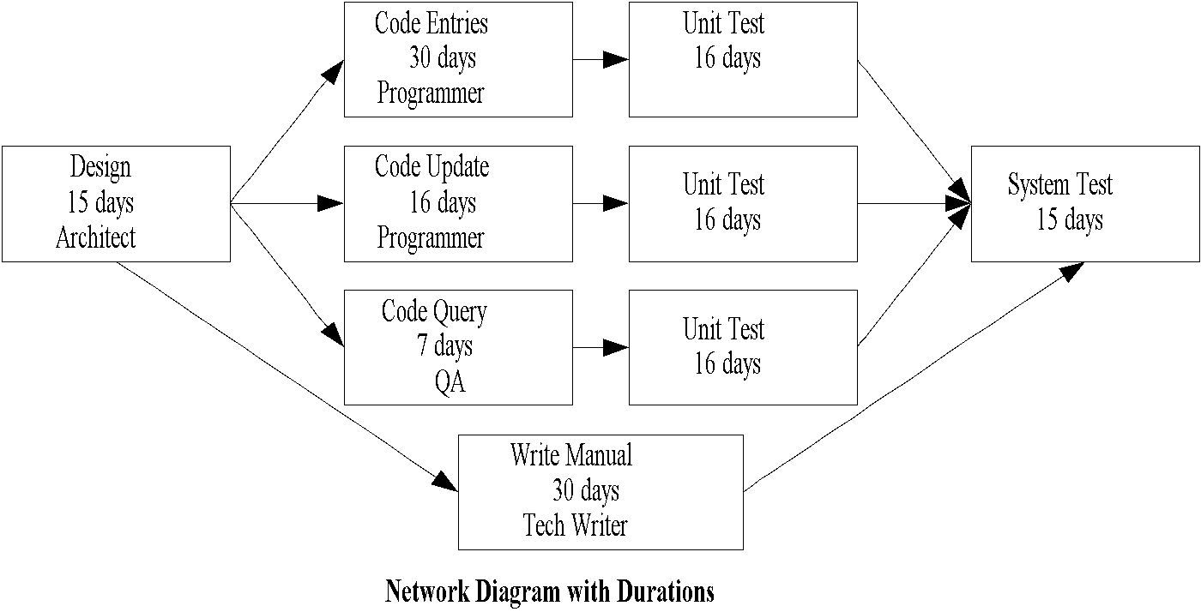

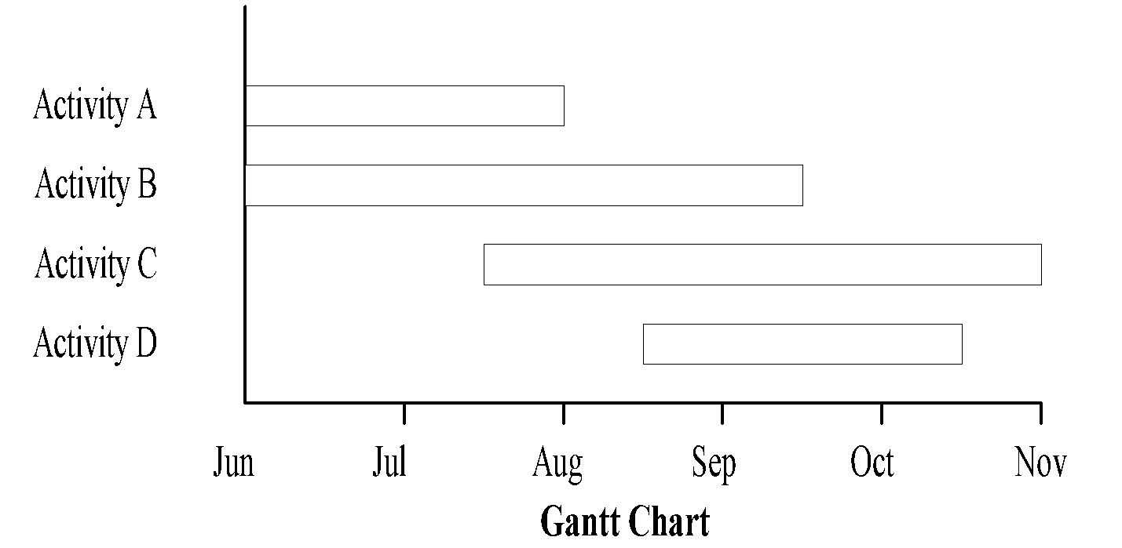

Gantt Timeline charts show activity start and end dates and expected durations on bars. The Gantt Timeline chart does not show dependencies nor slack, but is relatively easy to read and commonly used for project presentations.

For any type of project schedule, there are four types of dependencies or precedence relationships:

* Finish-to-start—the “from” activity must finish before the “to” activity can start
* Finish-to-finish—the “from” activity must be finished before the “to” activity can finish
* Start-to-start—the “from” activity must start before the “to” activity can start
* Start-to-finish—the “from” activity must start before the “to” activity can finish.

Every project schedule task should have at minimum:

* ID and WBS number for task identification during discussion and assignment
* Task name
* Task duration
* Planned Start and Finish dates (can also have actual start and finish dates)
* Prerequisites to show precedence relationships
* Percent complete
* Resources assigned
* You might also want costing information by assigning hourly rate to each resource and adding a Cost column to the schedule. The hourly rate will be multiplied by the duration of the task to assign cost information.

The PM should ensure they have documented any dependencies (mandatory or discretionary). It is recommended the project manager receive training for any project-scheduling tool to be able to use all the features of the tool.

## **Develop Project Management Plan**

The Project Management Plan is your project guide, outline, rules, and main communications tool and provides a documented basis for making project decisions and for confirming or developing common understanding of project scope among the stakeholders. It also serves as guiding document for project execution and control and provides the rules and limits for your project.

The main input for the Project Management Plan is the Project Requirements document and Project Schedule created above. The Requirements document will help with the project goal and objectives. The Project Schedule will provide project timelines and milestones.

You might select to perform the Risk Assessment prior to developing your Project Management Plan to allow you to highlight your Risk Mitigation or Risk Management Plan (more on this later).

The Project Management Plan should contain the following in the detailed level necessary for project information.

* The **Project Background** should introduce the client or customer environment leading to the change requiring the project. The information is collected during Requirements gathering.
* The **Project Goal** should provide a clear statement of what the project team will accomplish by project implementation. Proper scope definition is critical to project success and will avoid scope creep.
* **Project Objectives** should be measurable criteria that must be met for the project to be considered successful in terms of cost, schedule, or quality measures. The objectives will be matched to project deliverables during the project acceptance and closeout.
* The Project Management Plan should spell out and clear up any project ambiguities by documenting **Assumptions** and **Constraints**.

#### **Assumptions**

Assumptions are factors considered to be true, real, or certain. Assumptions generally involve a degree of risk and may be identified here or they may be a part of risk identification. A part of project management control, and also communications and documentation is to record your assumptions as part of the Project Management Plan to be covered later and have the customer validate those assumptions. Never assume anything on a project; write it down and have it validated!

#### **Constraints**

Constraints are factors limiting the project management team’s options. For example, if substantial project resources will be needed, more consideration will need to be given to handling contract information. When a project is performed under contract, there are often specific contractual provisions affecting communications planning.

* A project **Risk Assessment and Management Plan** should be completed prior to entering data into the Project Management Plan. A matrix of the high-risk items along with high-level management or mitigation plans to address the risk is provided in the Project Management Plan. **See Project Risk below**.
* After review of the requirements and Project Schedule, a **Staffing Plan** can be created for the project implementation. Resource planning involves determining what physical resources (people, equipment, materials) and what quantities of each should be used to perform project activities. It is a good practice to provide an organization chart for quick reference and define roles and responsibilities in this section of the Project Management Plan.
* The schedule section of the plan should contain your project WBS along with project milestones.
* After review of the Project Schedule, a **Cost Plan** and budget can be added to the Project Management Plan at the detail level required. In some cases, the Cost Plan might be preliminary until it can be updated with an addendum to the Project Management Plan during the Execute/Control Phase or as more details of the project become available. The budgeting of the project must be closely coordinated with cost estimating and will improve as more actual information is captured at the completion of many projects. **See Project Cost Plan Development below**
* All projects require a **Communications Plan** detailing what will be communicated, when it will be communicated, and who is going to do the communications. The Communications Plan is an important factor for project success because it ensures the proper communication flow and consistency. Determine the information and communications needs of the stakeholders such as:
  + Who needs what information?
  + When will they need it?
  + How will it be given to them?

The majority of communications planning is done as part of the earliest project phases but should be reviewed regularly throughout the project and revised as needed to ensure continued applicability. The PM should periodically as project stakeholders if they are getting the right kind and amount of information. The Communications Plan should provide an outline of the agenda for all status meetings so the project team and stakeholders know what to expect.

* If your project has procurement needs, a Procurement Plan should be completed.
* The Procurement Plan should provide the quantity and timing for all items needed. An inventory should be included upon receipt of any item on the Procurement Plan.

### **Project Cost Plan Development**

Cost budgeting involves allocating the overall cost estimates to individual work items to establish a cost baseline for measuring project performance. The project schedule identifies the project elements and includes planned start and expected finish dates for the project elements that costs will be allocated to. This information is needed in order to assign costs to the time period when the cost will be incurred.

**Cost baseline**

The cost baseline is a time-phased budget used to measure and monitor cost performance on the project and is developed by summing estimated costs by period.  Many projects, especially larger ones, may have multiple cost baselines to measure different aspects of cost performance. For example, a spending plan or cash flow forecast is a cost baseline for measuring disbursements.

**Cost Estimating**

Cost estimates are quantitative assessments of the likely costs of the resources required to complete project activities. They may be presented in summary or in detail.  Costs must be estimated for all resources charged to the project. This includes, but is not limited to, labor, materials, supplies, and special categories such as an inflation allowance or cost reserve.

Cost estimates are generally expressed in units of currency in order to facilitate comparisons both within and across projects. Other units such as staff hours or staff days may be used, unless doing so will misstate project costs (e.g., by failing to differentiate among resources with very different costs). In some cases, estimates will have to be provided using multiple units of measure in order to facilitate appropriate management control. Cost estimates may benefit from being refined during the course of the project to reflect the additional detail available.

When a project is performed under contract, care should be taken to distinguish cost estimating from pricing. Cost estimating involves developing an assessment of the likely quantitative result—how much will it cost the performing organization to provide the product or service involved. Pricing is a business decision—how much will the performing organization charge for the product or service—that uses the cost estimate as but one consideration of many.

Cost estimating includes identifying and considering various costing alternatives. For example, in most application areas, additional work during a design phase is widely held to have the potential for reducing the cost of the production phase. The cost estimating process must consider whether the cost of the additional design work will offset the expected savings.

Some of the tools the project manager can employ for cost estimating are:

**Resource rates**

The individual or group preparing the estimates must know the unit rates (e.g., staff cost per hour, bulk material cost per cubic yard) for each resource in order to calculate project costs. If actual rates are not known, the rates themselves may have to be estimated.

**Activity duration estimates**

Activity duration estimates will affect cost estimates on any project where the project budget includes an allowance for the cost of financing (i.e., interest charges).

**Historical information**

Information on the cost of many categories of resources is often available from one or more of the following sources:

* Project files—one or more of the organizations involved in the project may maintain records of previous project results that are detailed enough to aid in developing cost estimates. In some application areas, individual team members may maintain such records.
* Commercial cost estimating databases—historical information is often available commercially.
* Project team knowledge—the individual members of the project team may remember previous actuals or estimates. While such recollections may be useful, they are generally far less reliable than documented results.

**Analogous estimating**

Analogous estimating, also called top-down estimating, means using the actual cost of a previous, similar project as the basis for estimating the cost of the current project. It is frequently used to estimate total project costs when there is a limited amount of detailed information about the project (e.g., in the early phases). Analogous estimating is a form of expert judgment.  Analogous estimating is generally less costly than other techniques, but it is also generally less accurate.  It is most reliable when (a) the previous projects are similar in fact and not just in appearance, and (b) the individuals or groups preparing the estimates have the needed expertise.

**Parametric modeling**

Parametric modeling involves using project characteristics (parameters) in a mathematical model to predict project costs.  Models may be simple (residential home construction will cost a certain amount per square foot of living space) or complex (one model of software development costs uses 13 separate adjustment factors each of which has 5-7 points on it).  Both the cost and accuracy of parametric models varies widely.  They are most likely to be reliable when (a) the historical information used to develop the model was accurate, (b) the parameters used in the model are readily quantifiable, and (c) the model is scalable (i.e., it works as well for a very large project as for a very small one).

**Bottom-up estimating**

This technique involves estimating the cost of individual work items, then summarizing or rolling-up the individual estimates to get a project total.  The cost and accuracy of bottom-up estimating is driven by the size of the individual work items: smaller work items increase both cost and accuracy. The project management team must weigh the additional accuracy against the additional cost.

**Computerized tools**

Computerized tools such as project management software and spreadsheets are widely used to assist with cost estimating. Such products can simplify the use of the tools described above and thereby facilitate rapid consideration of many costing alternatives.

### **Project Risk**

Project Risk Management includes the processes concerned with identifying, analyzing, and responding to project risk, maximizing the results of positive events and minimizing the consequences of adverse events. The Risk Management Plan will be created before and during the time you create the Project Management Plan, as you will be looking at the tasks in the Project Schedule and other factors in the Project Management Plan for potential risk items.

#### **Risk Assessment and Management**

There are four steps to assessing and managing risks:

* Identify risks
* Review the task list from the Project Schedule
* Brainstorm and talk with the experts
* Over-allocations?
* Tasks with several predecessors
* Tasks with long durations or a lot of resources
* Quantify risks
* Determine your tolerance levels…how much risk can you bear to take?
* Assign a probability to each risk.
* Assign a cost to each risk if it does occur.
* Assign a priority to each risk.
* Plan for risks
* Identifying triggers for each risk
* Identifying management plans for each risk. If a risk does occur, you can respond by:
  + Accept = Do nothing in the project, but accept the risk is going to occur. Acceptance can be active (e.g., by developing a contingency plan to execute should the risk event occur) or passive (e.g., by accepting a lower profit if some activities overrun).
  + Avoid = Eliminating a specific threat, usually by eliminating the cause. The project team can never eliminate all risk, but specific risk events can be eliminated.
  + Mitigate = Taking early action to reduce the probability and/or impact of the impact of the risk occurring (e.g., prototyping a solution before implementation)

.

* + Transfer = Transferring the risk to a 3rd party such as using insurance, warranty, guarantee, or etc.
* Monitor and manage risks
* Review risks and potential risks at each status meeting
* It is important to understand even the most thorough and comprehensive analysis cannot identify all risks and probabilities correctly; control and iteration are required.
* A Risk Assessment and Management form has been supplied in the Templates Appendix. Add to the risk assessment questions as your project experience and exposure grows.

## **Develop Project Designs**

The Subject Matter Experts (SMEs) and Architect on the project team will complete the project design with information gathered during the business requirements survey along with additional detailed information from the client team and client environment.

The designs will progress from Conceptual, through Logical, to Physical for many project types. See Design Appendix for examples.

The design will be reviewed and validated before a final project design is created. All versions of the design should be placed in the project repository for reference. All design meetings should be documented and the Meeting Reports placed in the project repository.

## **Approve All Project Documents**

The completed project documents and designs should be submitted to management and the client for approval to allow the project to proceed (Gate 2). All Project Stakeholders and Project Team members should be briefed on the documents and the project manager should capture and manage expectations from the meetings.

## **Equip Project (optional)**

In some cases, equipment will be required for project execution. If you project calls for equipment, obtain the equipment and track the equipment via an inventory list (see Templates Appendix for an example).

# **Phase 3 – Implementation/Build Phase**

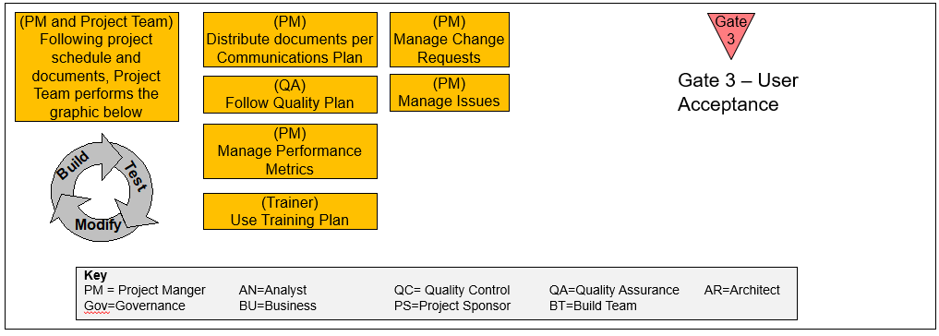The Implementation/Build phase is where the project team will implement or build the project deliverables based on all documents created up to this point. Each build process will be accompanied by parallel testing process to ensure the end product meets requirements and quality standards. During the Implementation/Deploy Phase, the vast majority of the project's budget and work effort will be expended. Because quality control and quality assurance is taking place at the same time as the creation of project deliverables; this phase also reviews, controls, and makes adjustments to the implementation/build effort. The purpose of this phase is to complete the project objectives and activities, identify and measure variances, and make adjustments when any significant variances occur.

The inputs to the Implementation/Deploy Phase are:

* All previous documents
* Project Schedule
* Project Designs

The Outputs are:

* Change Control Forms
* Project Status Reports
* Issues Matrix

## **Project Management Plan/Project Schedule Execution**

During this step, the Project Team, under the direction of the project manager, will perform the project tasks as outlined in the Project Schedule, Project Management Plan, and the Project Designs to fulfill the project objectives. Prior to the start of this step, hold a Kick-Off meeting with your project team to explain the current project environment along with roles and responsibilities. Review all the accepted project documentation to date. During this phase, the project manager must coordinate and direct the various technical and organizational interfaces that exist in the project. The project product is actually created during this step.

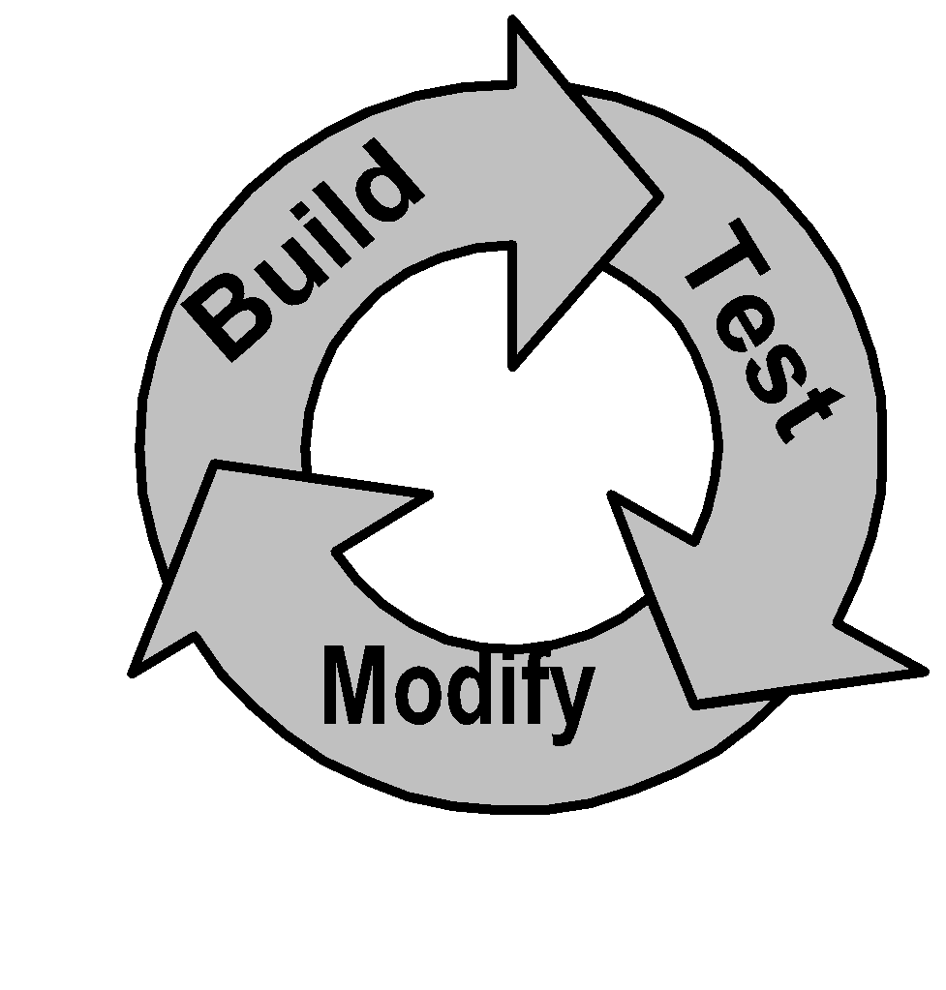

If this is an application development project, the project team will follow the cycle outlined in the graphic to the left. In order to keep the development flowing smoothly, the developers will be building while the quality team or QA team is testing. Any variance in the test results from the objectives of the project will result in a modification of the build process and the cycle will start again.

If changes are required, the change control process (See Change Control below) will be used and the Project Management Plan, project schedule, and other project documents may need to be modified as required for approved changes. The project manager will not only manage the activities, but also coach the project team as they perform their activities.

## **Verify Solution**

As the project solution is going through the process of Build, Test, and Modify for application development or Build for other project types; the solution should be installed in a pilot or test setup so acceptance tests can be run. The Subject Matter Experts on the Project Team will help create the acceptance test, which are accepted by the client. The tests are run on the pilot setup and the solution is modified per test results. The testing process is repeated until the solution meets the acceptance criteria agreed on by the client.

## **Control**

The focus of Control is to monitor and review the project’s progress against the plan; identifying when the project is off track and taking corrective actions as required.

Controlling the project is of major importance to a project team and project stakeholders because failure to execute and control the activities in a timely and organized manner can lead to major project delays and cost overruns.

## **Information Distribution**

Information distribution involves making needed information available to project stakeholders in a timely manner and can be aided by the use of a project repository, which provides client access to project documentation.

Information distribution requires the project manager and team members to:

* Review and implement the Communications Plan
* Conduct project meetings as needed to keep people informed
* Communicate all relevant project information informally and formally as needed through the project manager, the project focal point
* Identify and communicate barriers to project execution
* Attempt to respond to special requests for information from key stakeholders

Project team members are responsible for communicating effectively with one another as the project requires and forwarding all relevant project information to the project manager for disposition and broader distribution. If a project repository is used, the relevant project information is deposited directly to the repository where access controls can be applied.

Team meetings, e-mail, networked databases, enterprise document management systems, project management software, and the organization’s intranet can all be used to facilitate easy, effective, and timely distribution and recording of project information.

## **Change Control**

Overall change control is concerned with

* Influencing the factors which create changes to ensure that changes are beneficial
* Determining that a change has occurred
* Managing the actual changes when and as they occur

Change control requires all approved changes should be reflected in the Project Management Plan as changes to the product scope, as changes to the project timeframe (also noted in the project schedule), or as changes to the resource plan. Change Control is the act of coordinating changes across all knowledge and control areas of project management. For example, a proposed schedule change will often affect cost, risk, quality, and staffing.

The Change Control system includes:

* Monitoring performance to detect variances from plan
* Ensuring that all appropriate changes are recorded accurately
* Preventing incorrect, inappropriate, or unauthorized changes from occurring
* Informing appropriate stakeholders of authorized changes.

All change requests from the client will be delivered to the IT project manager using a Change Control Form. The project manager will investigate any impact on the project scope, schedule, or cost; review the Change Control Form with the project office or change control board if either is in place; and return the Change Control Form to the client with a description of any impact and any additional costs associated with the change request.

The Change Control Document will then be signed by the Client signifying acceptance of the changes to the project scope, cost, time, or resources; providing the ok to proceed with the amended implementation. Depending on the scope of the change, a Change Order may result in a new project to handle the requirements.

## **Report Performance**

Performance reporting involves collecting and disseminating performance information in order to provide stakeholders with information about how resources are being used to achieve project objectives. This process includes:

* Status reporting—describing where the project now stands
* Progress reporting—describing what the project team has accomplished
* Forecasting—predicting future project status and progress

Performance reporting generally provides information on scope, schedule, cost, and quality. Many projects also require information on risk and procurement. Reports may be prepared comprehensively or on an exception basis.

The project manager should collect regular updates on project progress from project team members, identify variances from plan and needed changes, collate and synthesize all the different inputs, summarize, and distribute the information to the team, project sponsor, and other stakeholders. The project manager’s summary should be brief yet comprehensive.

Although team meetings allow all team members to be apprised of project performance and problems, the project manager is able to have the best overall understanding of where the project stands and should communication the information to project stakeholders.

## **Quality Assurance**

Quality assurance is applied to ensure the project will satisfy the relevant quality standards and should be performed throughout the project. Some of the steps the project manager should take to ensure quality projects are:

* Review project deliverables prior to implementation using the project test plan
  + The earlier they any identified problems are fixed, the cheaper the solution
* Anticipate quality deviations and take preventive actions
* Test project and product processes prior to deployment
* Solicit early customer review and feedback

Ensure all quality assurance documentation is in the project repository and provided to all project stakeholders.

As the project progresses, the Project Office will ensure project quality by holding Project Quality reviews. A copy of the Quality Review form is in the Templates Appendix.

## **User Training**

In most cases, training the end user to operate or modify the deliverable is also a part of the project requirements, deliverables, or objectives. The project manager and Team should develop and present the training to the end user along with developing a permanent training plan for ongoing training. Some of the training will be on the job training as the solution is completed for acceptance. Other training is formal product training to allow the client to maintain, operate, or modify the end product after acceptance. All training should be tracked with a Training Plan to show when training is available, scheduled, and taken for client or team training (see Training Plan in the Templates Appendix).

To complete the Training Plan, enter the product and the name of the person needing the training in the spreadsheet. For each course, enter the dates corresponding to when the course is available, when it is scheduled, and when it is taken.

## **Prepare for Transition**

Prior to cutover and acceptance, the project manager will work with the client to prepare the transition and contingency plans. The Transition plan will outline the steps and the resources needed for an orderly transition to the new solution. The Contingency Plan will outline the steps to take to go back to the current solution should the transition plan fail for some reason.

One of the best ways to ensure success and minimize the risk of failure is to test the transition plan prior to transition.

## **Acceptance Testing and Approval**

Though the project team has performed the acceptance tests during pilot or during the build, test, modify cycle; the client completes one more acceptance test with the help of the project team. Using the acceptance tests and benchmarks agreed on in the Project Management Plan, the client will test the final solution for final acceptance. If modifications are necessary, to meet the client’s acceptance criteria, a retest is required. Once tests meet the criteria, document all test results.

# **Phase 4 – Deploy/Support Phase**

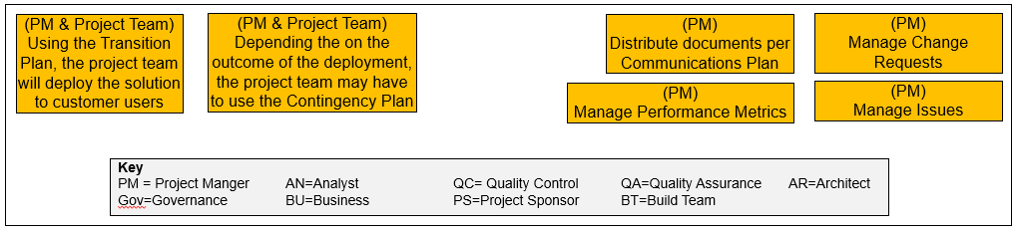The solution has been accepted and now the project team will transition customers to the new solution using the transition and contingency plan if needed. Depending on the terms of the contract, the project team may provide support during the transition and follow-on support after transition to ensure the solution is working as specified.

Ensure the customer has communicated deployment dates to keep everyone informed.

The inputs to the Deploy/Support Phase are:

* All previous documents
* Project Schedule
* Project Designs

The Outputs are:

* Change Control Forms
* Project Status Reports
* Issues Matrix

# **Close Phase**

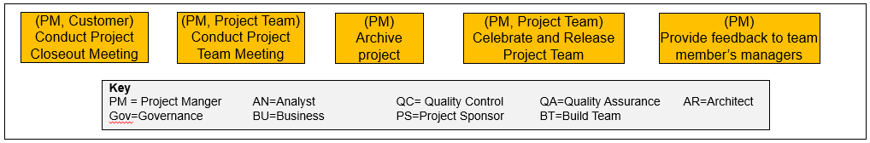

The Close phase brings the project to an orderly conclusion and retains its history for the benefit of subsequent projects. Tasks include final acceptance of the project, archival of project materials, reporting project performance, celebration, and release the project resources for use on other projects.

The purpose of this phase is to formalize the project completion and settlement of the contract or agreement with the client. Closeout is important to a project because it:

* Emphasizes to the client that the project objectives have been met
* Measures client satisfaction
* Archives project documents for future reference
* Optimizes opportunities for future business

Project closeout involves:

* **Administrative Closure**—generating, gathering, and disseminating information to formalize phase or project completion. Administrative closure consists of verifying and documenting project results to formalize acceptance of the product of the project by the sponsor, client, or customer. At this step, the project manager should ensure billing is completed to allow the project books can be closed. Administrative closure activities should not be delayed until project completion as each phase of the project should be properly closed to ensure important and useful information is not lost.
* **Contract Closeout**—completion and settlement of the contract, including resolution of any open items.

The Inputs of the Closeout Phase are:

* All Project Documents

The Outputs of the Closeout Phase are:

* Project Closeout Documents
* Project Document Archival

## **Conduct Project Closeout Meeting**

Conducting and documenting the project closeout review for a phase or project requires the project manager and team members to:

* Review and analyze the project records
* Prepare for the project closeout review by identifying things that went well, things that did not go well, lessons learned, and potential actions
* Organize a project closeout review meeting, including the project team and other key project contributors
* Match project objectives to project deliverables using the Closeout Report (see Templates Appendix)
* Capture project successes and what should be replicated in future phases or projects
* Capture project issues and what can be done to prevent their reoccurrence
* Acceptance for the product of the phase or project by the customer must be documented and made part of the project records

## **Project Team Meeting**

After the Acceptance Meeting with the client, the project manager should hold a meeting with the project team to capture Best Practices and Lessons Learned which should be stored in the project repository for future reference. Effective organizations strive to learn from their experiences in terms of what went well (and should be replicated) and what should be improved. Every project will experience successes and difficulties and it is important they are identified, analyzed, and communicated. In addition, corrective actions should be planned to prevent project problems from recurring in future phases or projects. Organizations improve through a continuous cycle of planning, doing, reflecting, and acting on what is learned. “Lessons learned” should become “Opportunities for Improvement.” Conducting and documenting the project closeout review for a phase or project requires the project manager and team members to:

* Agree on project successes and what should be replicated in future phases or projects
* Agree on project problems and what can be done to prevent their reoccurrence
* Assign ownership for implementing corrective actions (usually the project manager or PMO)
* Go over the review with the project sponsor if not present at the post-implementation review meeting
* Prepare a post-implementation review report and distribute it for others to learn from
* Post the report in the project repository

## **Archive Project Documents**

Any project creates a variety of documents during its life cycle, including those related to both the product of the project and the progress of the project itself. All project documents must be accumulated, verified, and archived for future use. Completing and archiving project documentation requires the project manager and team members to collect all project documentation, review the documentation to verify the completeness, accuracy, and the final revision levels, and archive the project records for future use.

## **Celebrate!!!**

As with any team effort, you should take time at the completion of the project, or even at the completion of a stage of a project if it is a long project to celebrate and recognize team member’s efforts.

## **Release Project Team Members**

At the conclusion of the project, the project manager should provide written performance feedback for each project team member and send it to the project team member’s manager. Before the form is sent to the employee’s personnel manager, the project manager should review each team member’s contribution with the team member and ask for feedback as appropriate.

## **Duties of the Project Manager During Closeout Phase**

* The project manager chairs the Closeout and Review meeting along with completing and distributing the Project Closeout form (See Templates Appendix)
* The project manager ensures all project documents are in the project repository prior to closeout
* The project manager plans for and manages the project celebration
* The project manager ensures all billing is handled
* The project manager ensures reviews are completed for all team members